**JAIPUR ENGINEERING COLLEGE AND RESEARCH CENTRE**

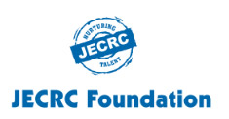

**Department of Applied Science**

**REPORT**

**ON**

**Slogan Writing and Cleanliness Drive**

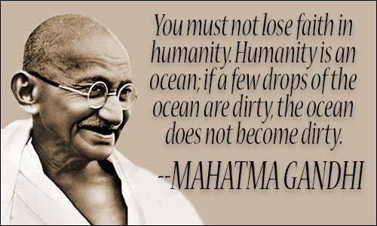

The **“Slogan Writing Competition and Cleanliness Drive”** was organized by the **Department of Applied Science** on the occasion of birth anniversary of the Mahatma Gandhi in C – Block, dated 02 October, 2019.

.

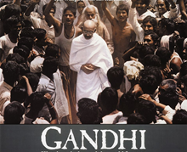

In Slogan writing competition, 20 students participated with great zeal, enthusiasm and patriotism.

Topics for slogan writing were as follows:

**1. Importance of Cleanliness**

**2. Vision of Mahatma Gandhi for the Nation**

**Best three Slogans were felicitated with e-certificate & I, II, III prizes**

Winner of the event was Ms. Vidhi of First Year CSE IInd Shift.

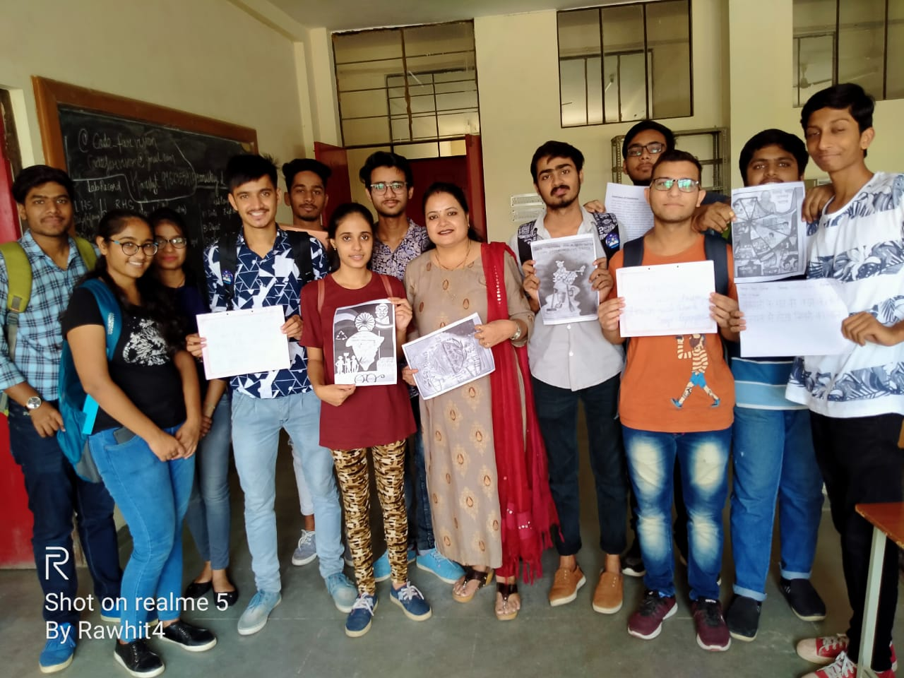

HODs gave away the prizes to the winners and proposed a vote of thanks.

On the same Day students and Faculty Members of Department of Applied Science participated in cleanliness drive. Everyone was determined for the cleanliness of the surroundings.

To motivate students and Faculty members Honorable Vice Chairman Sir, Principal Sir and Senior Advisors of the College also participated in the drive.

